|  |  |
| --- | --- |
| DATE: | 15/11/2022 |
| TEAM ID: | PNT2022TMID46314 |
| PROJECT: | REAL-TIME COMMUNICATION SYSTEM POWERED BY AI FOR SPECIALLY ABLED |
| MARKS: | 4MARKS |

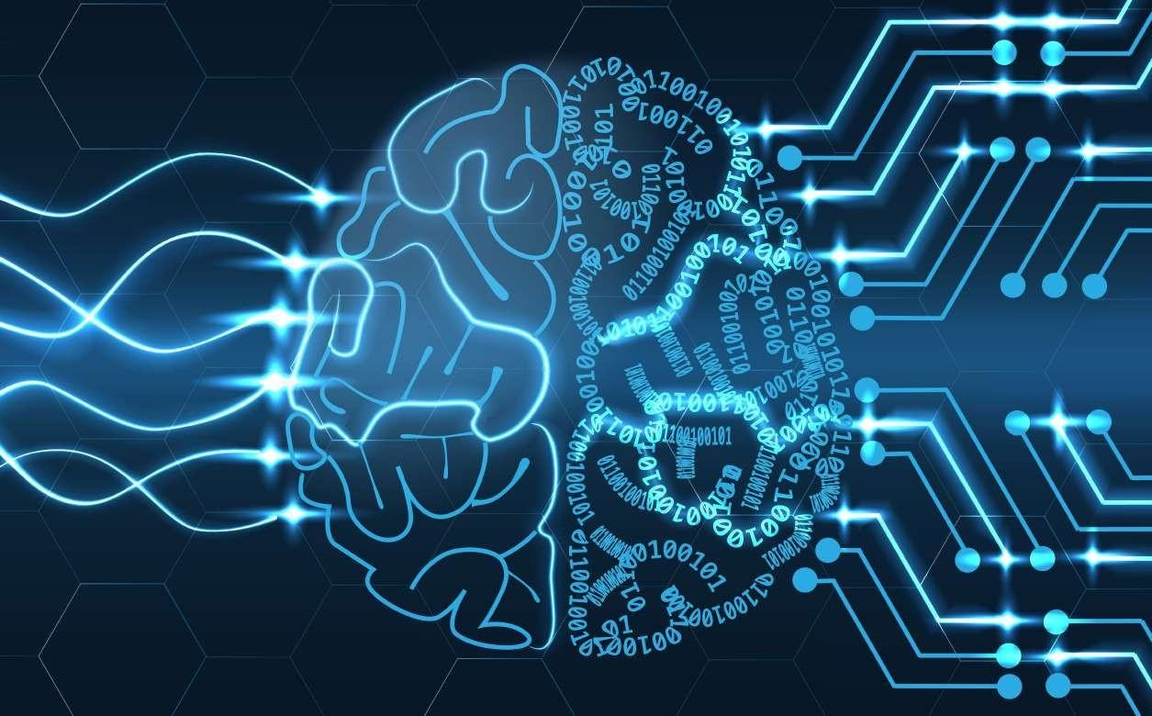

Empathy Map Canvas

Gain insight and understanding on solving customer problems.

Build empathy and keep your focus on the user by putting yourself in their shoes.

1

Specially abled It's a miracle

person can feel thing that we

like normal able to live

people with the independently.

help of AI.

**AI increases Next generation of It's a great feeling Quick**

**quality and people and that we able to**

**patient safety by economy of them communicate with responses**

**increasing will depends on normal people with**

**predictability and Artificial the help of AI in output**

**technology.**

**consistency. Intellegence.**

**Helps in betterment of**

**Latency issues lifestyle for Users are**

**may lead to differently happy Take time to**

**major problems adjust with**

**especially in abled. the new**

**medical field. Technology**

**sometimes may convey improper messages.**

**Leads to technologically advanced society.**

**Equivalent to human intelligence.**

**Difficult to implement and demonstrate**

This project was very helpful impaired for people.

**There is no language barrier**

**It is very difficult**

**to convey the message to normal people**

**Normal people could not understand their message**

**In emergency times conveying their message to normal people is difficult**

**It is very useful to have proper conversation between a normal person to impaired person**

**Easy to communicate with people**

**Able to communicate with real time world.**